“Quality, Fairness, Value”

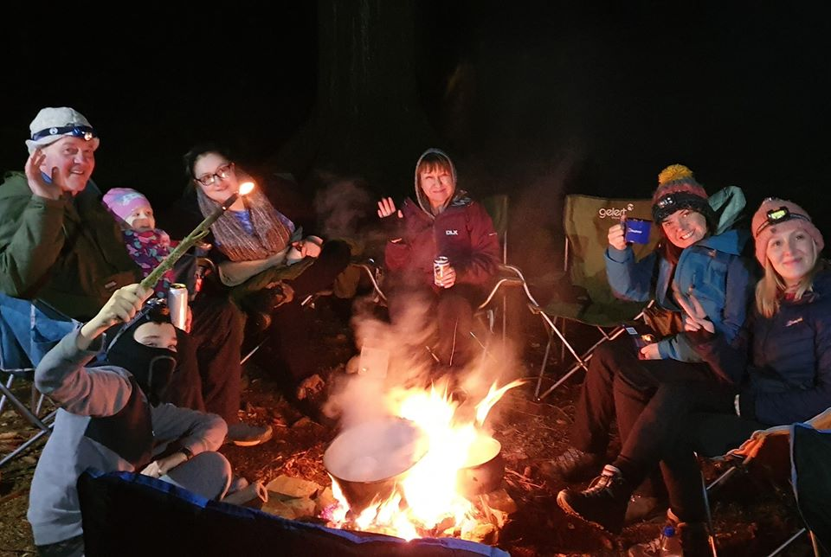

The Scottish Experience

Description:
The Mountain Men bring you a new and unique way to tour Scotland. Our wild camping “experiences” will take you to places other tour operators do not reach, we will show you sights you won’t get from a coach, take you into the very heart of Scotland’s beauty and make memories not many people make.
We will not only show you some of the more remote places in Scotland, you will get to spend the night at these stunning locations, dine under the stars and view the vast expanse of the Milky Way from your chair, enjoy some of the most spectacular sunsets this planet has to offer and wake in the morning feeling relaxed and refreshed for another day of discovery.

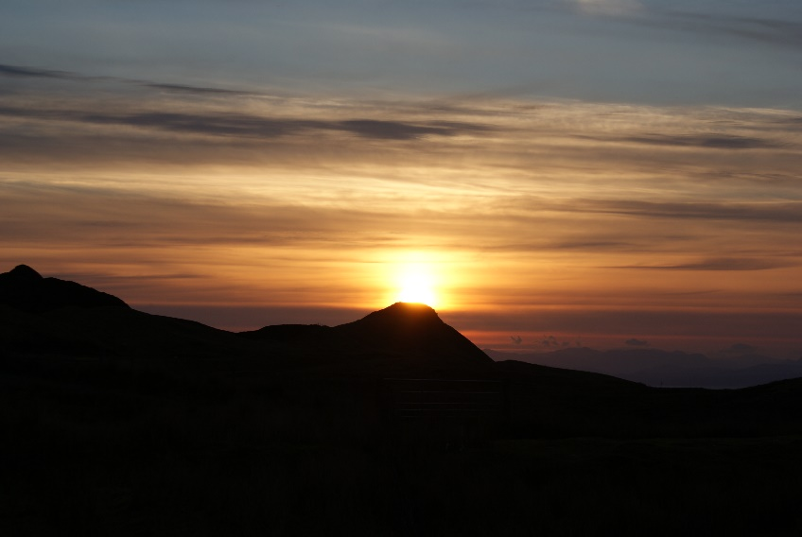

No matter which of our “Scottish Experiences” you choose we will offer you memories no other tour operator offers, our 5 star treatment will leave you wanting more and we are confident when you leave us we will part as friends and you will already be thinking about your next “Experience”
It is no coincidence we have been awarded “Tour Company of the Year: Scotland” In the 2020 Travel and Hospitality Awards.

Who are The Mountain Men?

The Mountain Men are organised and run by Ritchie Nash, a family man and ex Scottish Infantry soldier. Ritchie prides himself in making The Mountain Men the best they can be and on giving you the best experience possible. Three watchwords, "Quality, Fairness and Value."
Not just words to The Mountain Men, they are our promise to you and ourselves to be the best, to give you the best, to ensure we don't just give you a tour, we give you an Experience, a very Scottish Experience.

The Mountain Men Ltd
Registered in Scotland: SC611785
2nd Floor, Clyde Offices
48 West George Street
Glasgow, G2 1BP

0141 4827005

info@mountainmen.scot
www.mountainmen.scot

included within:

- The BackPacker Experience
- The Skye Experience
- The Arran Experience
- The NC500 Experience
- The Scotland Experience
- The Tailored Experience

The BackPacker Experience

Description:
Our BackPacker Experience is the ultimate in wild camping in Scotland. An all-inclusive package we supply everything you need from a rucksack to a head torch and everything in between.
The BackPacker is designed to get you out, to show off Scotland and to take you away from the normal tourist spots. As the name suggests there is an amount of walking involved and carrying a pack. Nothing we do and nowhere we take you will be beyond your limits no matter what your level of fitness is.
If you want to see those lesser known, less accessible beauty spots in Scotland then the BackPacker Experience is the way to do it.

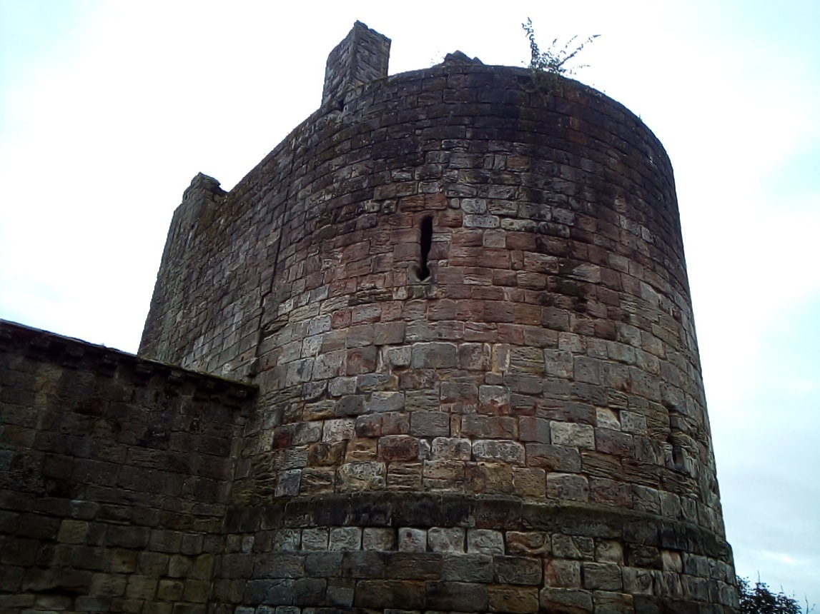

Now despite the fact you will be carrying everything you need in a pack on your back there is no need to worry, we will supply you with the best of equipment to ensure a comfortable night and as the gear is all lightweight it will not break your back. An average pack will weigh between 10 – 12kg depending on any extra stuff that you bring. A word on that, you can bring with you some luxury items and maybe a change of clothes but there is really no need for you to worry about equipment, we even supply toilet wipes and hand sanitiser in your pack. We really have thought of everything.

A Typical BackPacker:
Your day will start with pick-up, we will arrange with you a suitable local pick up location, a main street close to where you live (as best as is practicable). Once all pick-ups are complete and we have a cup of coffee or tea we will make our way on our journey. Exactly where you are going will be a mystery to you, we live the big reveals.
On route we will stop somewhere for lunch, a local pub, café or even restaurant depending on what is available, lunch is not included in the cost so it is entirely optional, you are welcome to bring a packed lunch with you if you prefer.
After lunch we will be making our way to your night-time destination, don’t be fooled by direction though as we are masters of deception, you may be travelling South and end up North, it’s all a mystery.
Whilst travelling we will try to make your journey as interesting as possible, if there is something on route we simply should visit then we will, it may be a castle, a beach, a waterfall etc, our job is to showcase Scotland and her beauty and culture, we will do this in Mountain Men style, relaxed and no time pressure.
And then on to the night location and we promise you it will be simply stunning.

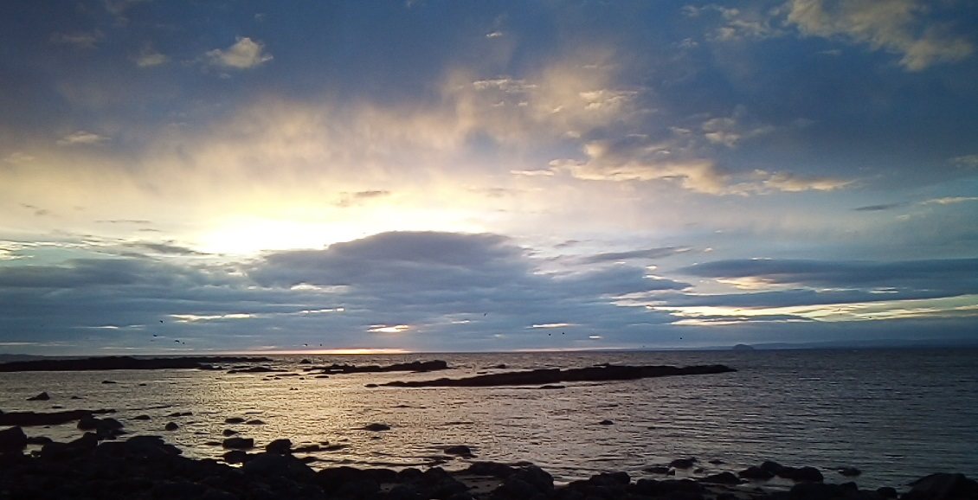

On arrival at the night-time location we will prepare camp, we will always have a minimum of one Mountain Man on hand and we will assist in setting up the tents and the camp.
Once camp is set you are free to explore, there are no timings for dinner or indeed breakfast, you will have your own stove and cooking gear and can therefore make dinner whenever you feel hungry, brew up in your own time etc. Most meals will be boiled in the bag so no need to pack culinary skills. In the morning you can breakfast at your leisure, we are not going to hurry you away, enjoy the relaxation, have a lie in, wake early to explore more, your decision.

What’s Included in your BackPacker Experience?
- Transport both ways from local pick up point (as near as possible)
- Choice of Dinner and Breakfast, (vegetarian options will be available)
- Tea and Coffee packs
- Fully packed rucksack with everything you need from tent and sleeping bag to toilet items
- Driver/Guide

What’s not included:
- Lunch
- Entry to any attraction we stop at
- Return travel from your pickup location (we will endeavour to come as close to you as practicable)

Cost:
Currently the BackPacker Experience retails at £87.50 per person (incl all taxes). Family and Group bookings may attract a discount, please enquire prior to booking.

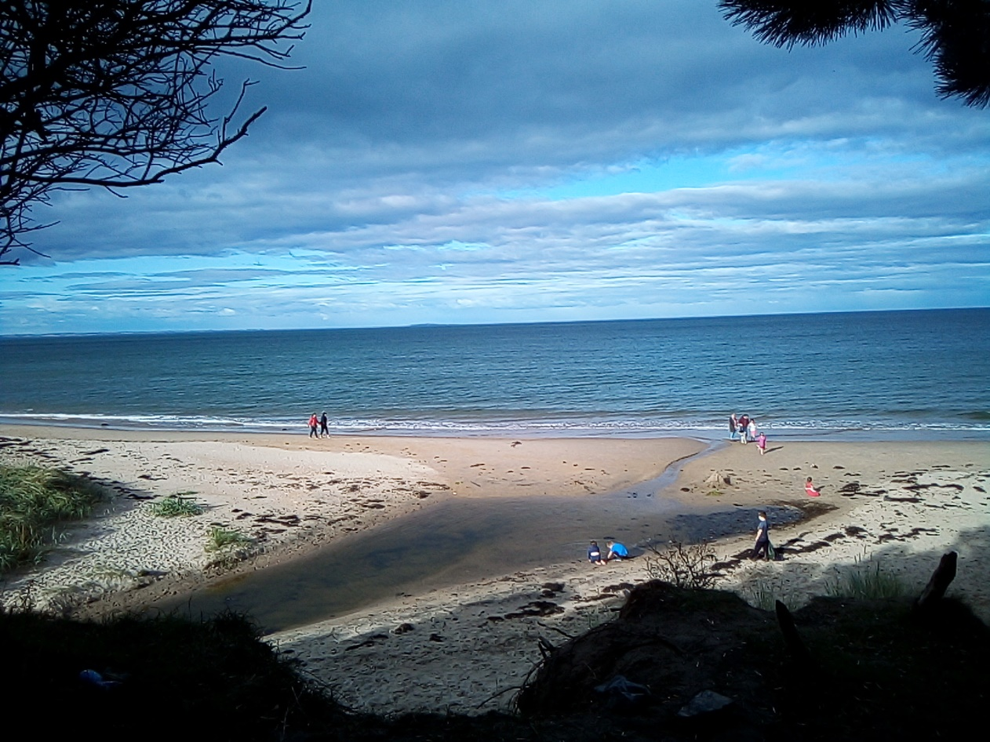

The Skye Experience

Description:
Our 3 day/2-night Skye Experience is possibly the best way to see this magical island. An all-inclusive package we supply everything you need from large walk in tents, folding cot beds, comfy outdoor chairs and even a covered portable toilet.
Skye is full of interesting places you really need to see, The Fairy Glen, Kilt Rock, The Quiraing, Lealt Falls and many more. Fortunately, we are familiar with the island and know how to get round it with minimum fuss and show you the delights in a relaxed manner.
A haven for the tourists this island attracts visitors from all over the world but that does not mean there are not quieter areas for us to spend the night, come with us and we will camp in places you will fall in love with.

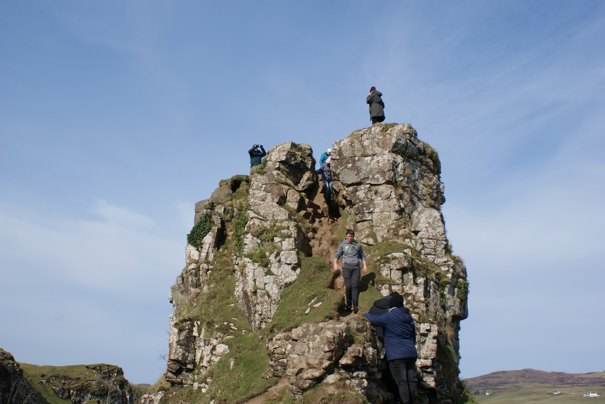

The Skye Experience is more wild glamping than wild camping, it is a bit more luxurious than you may expect. Our tents are bigger and include folding cot beds and we ensure you have enough space to relax at night. Sitting around the campfire at night in a comfy chair with a wee drink and some banter in such surroundings just may be one of your lifelong memories you never want to forget.

A Typical Skye Experience:
Your day will start with pick-up, we will arrange with you a suitable local pick up location, a main street close to where you live (as best as is practicable). Once all pick-ups are complete and we have a cup of coffee or tea we will make our way on our journey. Our route to Skye will take us past places such as Glencoe, Fort William, The Great Glen and the Kyle of Lochalsh amongst others. We will have plenty of time to stop for photo’s refreshment and convenience breaks.
Before we hit Skye itself we will see Eilean Donan Castle, they say it is the most photographed castle in Europe, possibly the world. Not only will you get a chance to add to the photo tally but we have included the audio tour of the castle in your package. None of us have ever actually been inside but our guests seem to love it.
After Eilean Donan we will cross the bridge to Skye and very quickly after we will stop and introduce you to Arnie and his family, he serves possibly the best fish n chips (amongst other stuff) you will ever have. (we have been known to visit more than once on request).

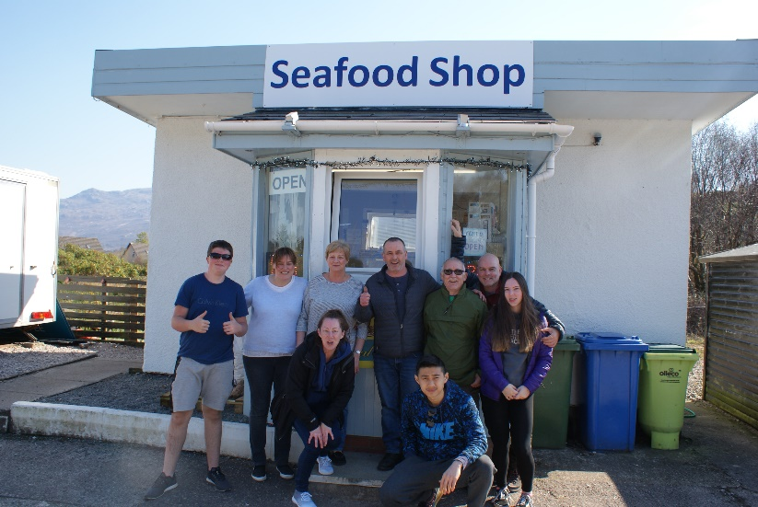
After lunch we will begin the trip around Skye, depending on the time of year and the amount of daylight we may get a chance to see a few places before heading to camp, we may decide to camp earlier if the weather suggests.
When we do come to camp we will all muck in and be set in no time, once set we will begin the dinner process whilst you can explore, relax with a wee drink , set yourself up fo the night, whatever you choose.

Our outdoor culinary skills may not rival Gordon Ramsay but for dinner we will serve up some decent grub, maybe a chilli, stew, burgers or similar, there will be a vegetarian option on request. With dinner out the way and a bit of clearing up we can sit back, enjoy the evening and if lucky the night skies before heading off to bed, here we have no timings, go to bed when you want, get up when you want, our tents have black out bedrooms so the morning light should not disturb you. If you are an early riser well so are we and it is likely one of us will be a round and the coffee on the go, if we are not around help yourself .
Day 2 will start proper after breakfast and packing is complete, we will continue on the theme of seeing the sites and whilst these will differ from day 1 the theme of relaxation, enjoyment and great company will continue, you will have a second night camp (different location) and day 3 will see us start to make the journey home, that does not mean it is all over, far from it, there will be plenty to see and do on route back to your pick up location.

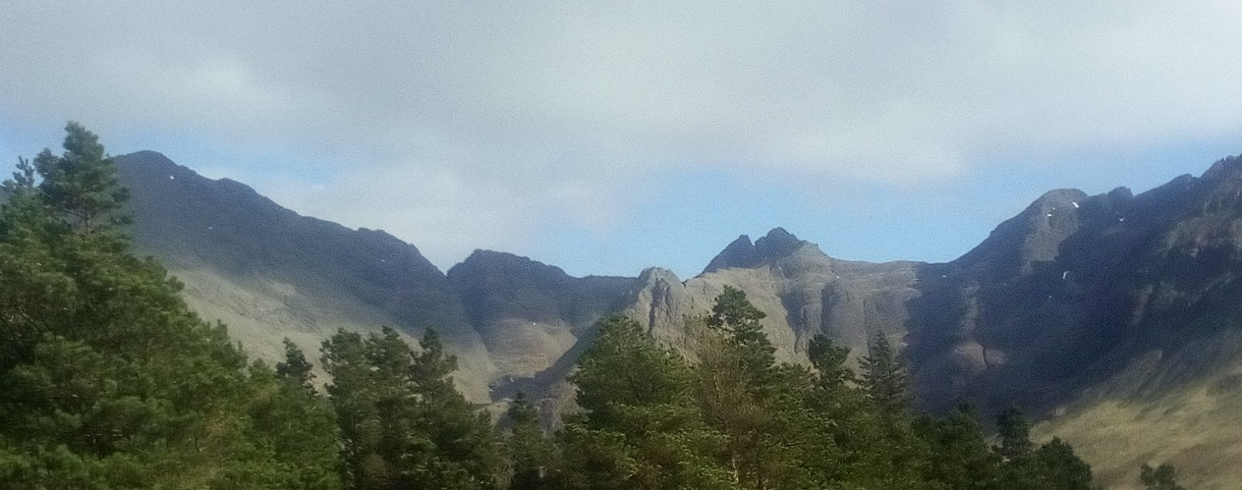

What’s Included in your Skye Experience?
- Transport both ways from local pick up point (as near as possible)
- Dinner and Breakfast, tea, coffee, soft drinks (vegetarian options will be available)
- Tour of Eilean Donan Castle
- All equipment for overnight camping including a covered portable toilet
- Driver/Guide

What’s not included:
- Lunch
- Entry to any attraction we stop at (other than Eilean Donan Castle)
- Return travel from your pickup location (we will endeavour to come as close to you as practicable)

Cost:
Currently the Skye Experience retails at £99.00 per person (incl all taxes). Family and Group bookings may attract a discount, please enquire prior to booking.

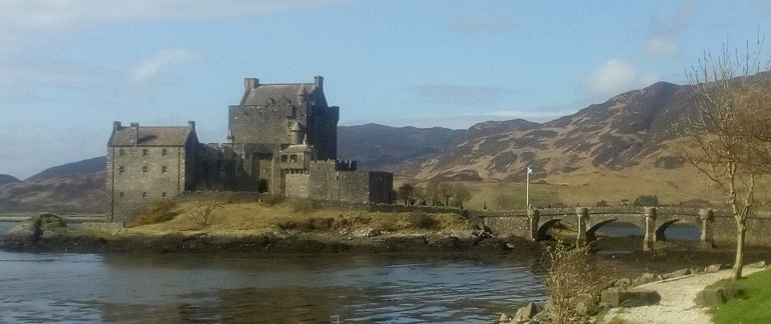
The Arran Experience

Description:
Our 3 day/2-night Arran Experience is new for 2020 and already proving to be a popular choice. Described as Scotland in Miniature the island of Arran has a lot to offer, it’s rugged coastline, sandy beaches, mountains and forests describing Scotland’s landscape perfectly. If this is not enough there are castles, standing stones, wildlife and even its own distillery, you may by now be beginning to understand why it is so popular.
Our Arran Experience is based on The BackPacker Experience which means we are using lightweight gear and there will be a small amount of packing kit into the camp locations, nothing too strenuous however so suitable to all. We have gone the BackPacker route because it allows us to take you to the better night- time locations.

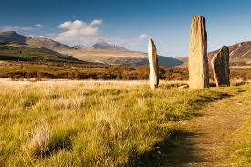

For this experience we will supply all the equipment you need for comfortable night, your kit will include the following:
Rucksack
Tent (possibly shared)
Sleeping Mat
Sleeping Bag
Cooker and pot set
Head torch and spare batteries
Toiletries incl sanitiser
Food and drink packs (you select)
Water

A Typical Arran Experience:
This is a 3-day and 2-night all-inclusive experience. It will start with pick-up, we will arrange with you a suitable local pick up location, a main street close to where you live (as best as is practicable). Once all pick-ups are complete and we have a cup of coffee or tea we will make our way on our journey. Our route to Arran will take us to Ardrossan where we will board the ferry for Brodick, the journey across to the island takes around 55 minutes and there will be time for a leg stretch and a coffee or something stronger if it is available. Enjoy the views as the boat crosses the Firth of Clyde.
Once on Arran we will take stock and begin our adventure, how we move around the island and what we see when will be down to you as a group, we will guide you throughout and advise you as to how to get the most of the island, we will keep an ever watchful eye on the weather as this may dictate to us the best way of doing things.
Despite being a small island of only 167 square miles there is plenty to see. You will likely want to visit Brodick and/or Lochranza Castle, the Machrie Moor Standing Stones and The Kings Cave, there is the Arran Distillery and if whisky is not your tipple the Arran Brewery and of course Goatfell, Arrans highest mountain which rises to 2,866 feet above sea level and affords outstanding views. Whatever you want to see we will be there to make it happen.

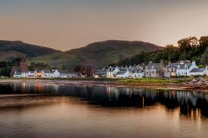
There is no rush to get around Arran and we will guide you in true Mountain Men style, that means relaxed and no pressure, we have said it before, you can’t rush beauty, nor should we. Your time with us should be about stepping back from the hustle of everyday life and just taking a break.
Each evening we will set up camp and once done you can wander freely and explore, the BackPacker allows more freedom, your dinner and breakfast are simple and tasty and take no real effort to prepare and you can set that whenever you are hungry, you will have a drinks pack which means you can brew up when you want, you are not beholden on anyone else, of course if you need assistance we will be there to help. When ready to settle we will be there with a campfire going. Go to bed when you want, rise when you want, what more would you want?
You may decide you want to climb Goatfell whilst on the island, as with all Scotland’s mountains a degree of common sense and the right equipment is required, if you think it is on your wish list then please speak to us prior to departure, we will check all conditions and advise you accordingly, if you need some training on navigating the mountain we can even do that. Whilst not the hardest mountain in Scotland it will still take a bit of time.

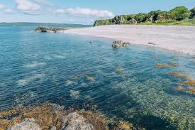

What’s Included in your Arran Experience?
- Transport both ways from local pick up point (as near as possible)
- Dinner and Breakfast, tea, coffee, soft drinks (vegetarian options will be available)
- Return Ferry Crossing
- All equipment for overnight camping as described above
- Driver/Guide

What’s not included:
- Lunch
- Entry to any chargeable attraction we stop at
- Return travel from your pickup location (we will endeavour to come as close to you as practicable)

Cost:
Currently the Arran Experience retails at £99.00 per person (incl all taxes). Family and Group bookings may attract a discount, please enquire prior to booking.

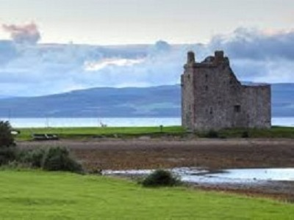
The North Coast 500 Experience

Description:
Scotland’s Route 66 as it is described, our very own road trip or one of a few. This 4 day/3 night Experience is too stunning for words to do it justice, reveal after reveal of sheer majesty and beauty. Landscapes so rugged it will be difficult to imagine how people used to survive, beaches so glorious you will think you are on a Caribbean waterfront, history so heart breaking you will be moved to tears, yes the NC500 has it all and we know the best way to show it to you.
For this all-inclusive package we supply everything you need from large walk in tents, folding cot beds, comfy outdoor chairs and even a covered portable toilet.
Relatively new to the tourist market this route gets busier every year, it won’t take long for you to understand why? The actual 500 starts and finishes in Inverness and covers 508 miles from start to finish, come with us though and it will be closer to 539 miles as we know some places off the beaten track which just must be seen.

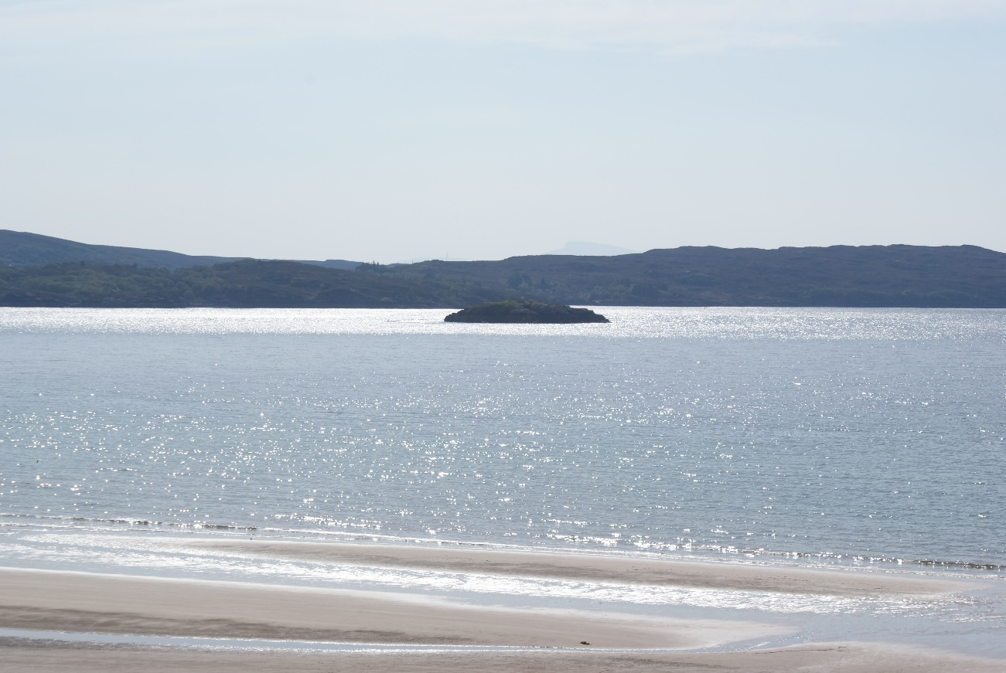

The NC500 Experience is more wild glamping than wild camping, it is a bit more luxurious than you may expect. Our tents are bigger and include folding cot beds and we ensure you have enough space to relax at night. Sitting around the campfire at night in a comfy chair with a wee drink and some banter in such surroundings just may be one of your lifelong memories you never want to forget.

A Typical NC500 Experience:
Your day will start with pick-up, we will arrange with you a suitable local pick up location, a main street close to where you live (as best as is practicable). Once all pick-ups are complete and we have a cup of coffee or tea we will make our way North to Inverness, here we will stop to fuel up ready for the 500 and for some lunch in this beautiful city. After Inverness we will continue North over the Kessoch bridge and onto the Black Isle before coming to our decision point of West first or North first. Travelling round the NC500 is done clockwise or anti clockwise and whatever way we go the views will be completely different, this is not a major concern as we will take time to stop and look backwards at key moments. We will know what way round we are going before we arrive as we will have already selected the best way to make the most of Scotland’s infamous weather.
Whatever way we go you are going to be amazed. Day 1 is a long day as we have to get to the start point which means a lot of miles are covered on this day but we cover these miles as only we can, laid back, relaxed and with plenty of stops for photo’s, coffee and convenience breaks. It may be a long day but it will be a stunning day.

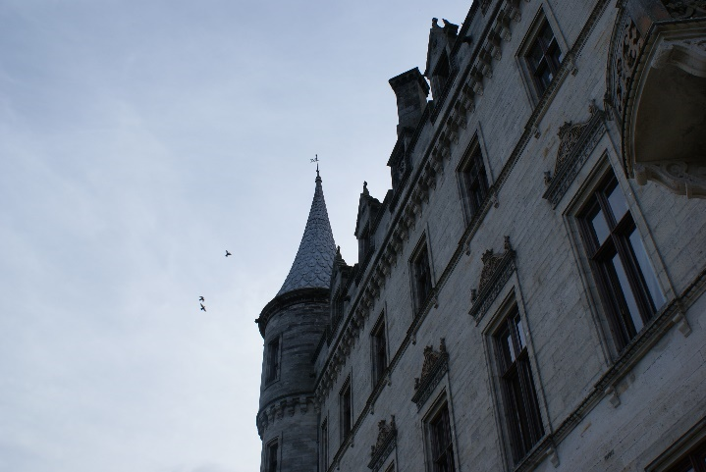
No matter what way we are heading you will have plenty to see and do, there are castles, beaches, viewpoints, waterfalls, distilleries and much more for you to visit throughout the route.
Each evening when we come to camp we will all muck in and be set in no time, once set we will begin the dinner process whilst you can explore, relax with a wee drink , set yourself up for the night, whatever you choose.

Our outdoor culinary skills may not rival Gordon Ramsay but for dinner we will serve up some decent grub, maybe a chilli, stew, burgers or similar, there will be a vegetarian option on request. With dinner out the way and a bit of clearing up we can sit back, enjoy the evening and if lucky the night skies before heading off to bed, here we have no timings, go to bed when you want, get up when you want, our tents have black out bedrooms so the morning light should not disturb you. If you are an early riser well so are we and it is likely one of us will be around and the coffee on the go, if we are not around help yourself .
Day 2 and 3 are a lot more relaxed and will start proper after breakfast and packing is complete, we will continue on the theme of seeing the sites and whilst these will differ from day 1 the theme of relaxation, enjoyment and great company will continue, you will have a second and a third night to camp (different location each time) as we continue on this outstanding road trip, we really cannot sell this one enough, it is a trip of a lifetime. Day 4 will see us start to make the journey home, that does not mean it is all over, far from it, there will be plenty to see and do on route back to your pickup location.

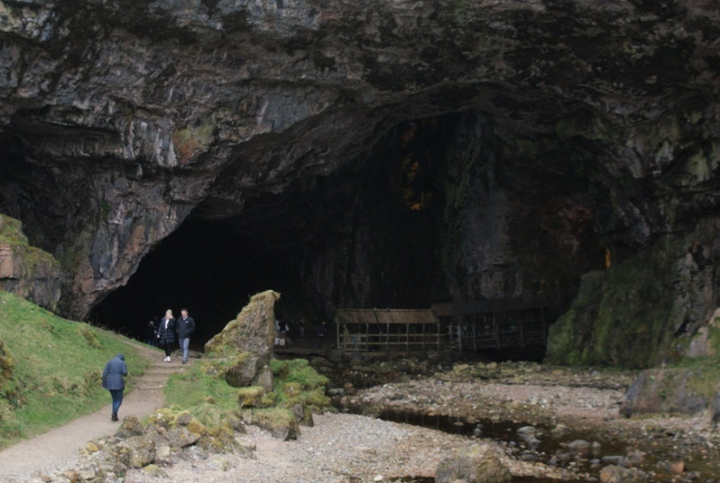
What’s Included in your NC500 Experience?
- Transport both ways from local pick up point (as near as possible)
- Dinner and Breakfast, tea, coffee, soft drinks (vegetarian options will be available)
- All equipment for overnight camping including a covered portable toilet
- Driver/Guide

What’s not included:
- Lunch
- Entry to any attraction we stop at
- Return travel from your pickup location (we will endeavour to come as close to you as practicable)

Cost:
Currently the NC500 Experience retails at £149.00 per adult, (incl all taxes). Family and Group bookings may attract a discount, please enquire prior to booking.

The Scotland Experience

Description:
This is both the Skye and North Coast 500 Experiences brought together for over 1000 miles of stunning landscapes and beautiful views. 5 days and 4 nights covering some of Scotland’s most iconic locations. Inverness, John O’ Groats, Durness, Ullapool, Skye, Fort William, Glencoe and Rannoch Moor amongst other amazing places.
Your camera is going to be busy and in the evenings’ you will have lots to discuss and reflect back on or look forward to. There are many ways to tour Scotland, not only do we think we have the best way to do so but try and match the price with another tour operator.
For this all-inclusive package we supply everything you need from large walk in tents, folding cot beds, comfy outdoor chairs and even a covered portable toilet.

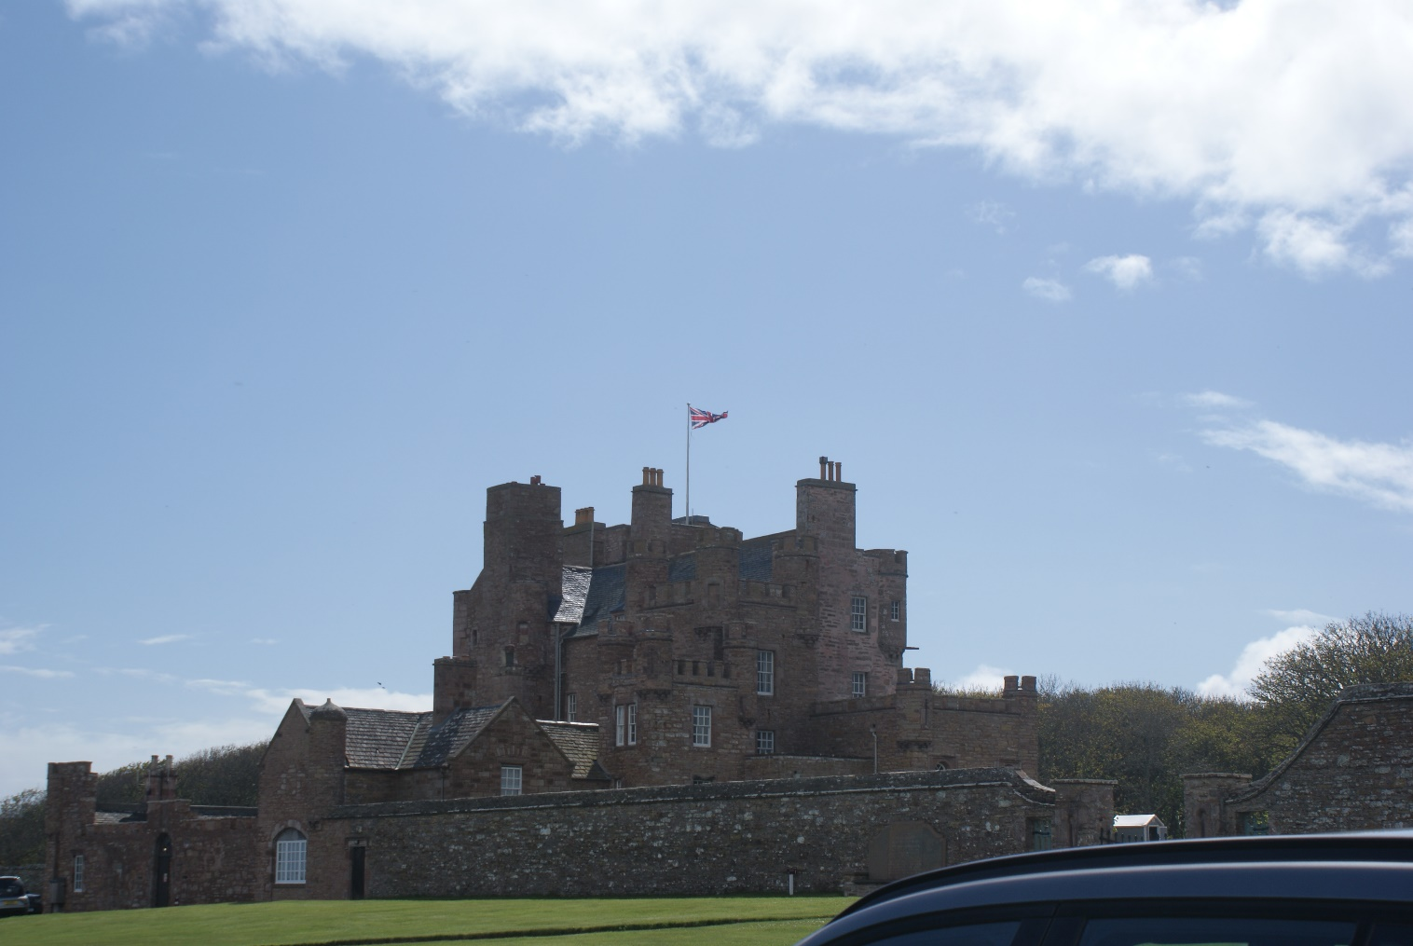

The Scotland Experience is more wild glamping than wild camping, it is a bit more luxurious than you may expect. Our tents are bigger and include folding cot beds and we ensure you have enough space to relax at night. Sitting around the campfire at night in a comfy chair with a wee drink and some banter in such surroundings just may be one of your lifelong memories you never want to forget.

A Typical Scotland Experience:
Due to our ever changeable weather there won’t ever really be a typical Scotland Experience, however rest assured we will take everything into account to ensure we take you round Scotland in such a way that we get the best experience possible for you. You may head North towards the Highlands or West towards the islands depending on what makes sense at the time.
As per standard your experience will start with pick-up, we will arrange with you a suitable local pick up location, a main street close to where you live (as best as is practicable). Once all pick-ups are complete and we have a cup of coffee or tea we will make our way on this amazing adventure. You are sure to have days filled with wonder and views you simply won’t want to walk away from, there is a reason Scotland has been voted The Most Beautiful Country in The World and we aim to show you as much as we can fit in.
Whatever way we go you are going to be wowed.
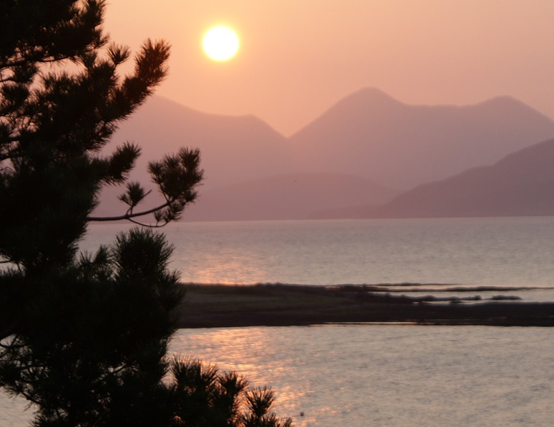
Look forward to castles, beaches, viewpoints, waterfalls, distilleries, lochs and much more for you to visit throughout the week.
Each evening when we come to camp we will all muck in and be set in no time, once set we will begin the dinner process whilst you can explore, relax with a wee drink , set yourself up for the night, whatever you choose.
Our outdoor culinary skills may not rival Gordon Ramsay but for dinner we will serve up some decent grub, maybe a chilli, stew, burgers or similar, there will be
a vegetarian option on request. With dinner out the way and a bit of clearing up we can sit back, enjoy the evening and if lucky the night skies before heading off to bed, here we have no timings, go to bed when you want, get up when you want, our tents have black out bedrooms so the morning light should not disturb you. If you are an early riser well so are we and it is likely one of us will be around and the coffee on the go, if we are not around help yourself .
Days 2, 3 and 4 will be a lot more relaxed and will start proper after breakfast and packing is complete, we will continue on the theme of seeing the sites and whilst these will differ from day 1 the theme of relaxation, enjoyment and great company will continue, you will have 4 night camps in total(different location each time) as we continue on this outstanding road trip, we really cannot sell this one enough, it is a trip of a lifetime. Day 5 will see us start to make the journey home, that does not mean it is all over, far from it, there will be plenty to see and do on route back to your pickup location.

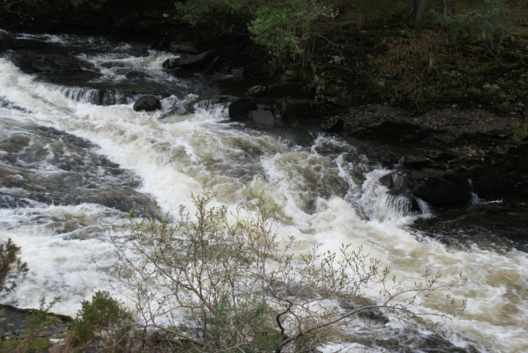
What’s Included in your Scotland Experience?
- Transport both ways from local pick up point (as near as possible)
- Dinner and Breakfast, tea, coffee, soft drinks (vegetarian options will be available)
- All equipment for overnight camping including a covered portable toilet
- Driver/Guide

What’s not included:
- Lunch
- Entry to any attraction we stop at
- Return travel from your pickup location (we will endeavour to come as close to you as practicable)

Cost:
Currently the Scotland Experience retails at £205.00 per person, (incl all taxes). Family and Group bookings may attract a discount, please enquire prior to booking.

The Tailored Experience

Description:
It is 2020 and not everything comes neatly packaged in a box. Here at The Mountain Men we are aware of differing needs and we strive to offer the most complete get away possible.
To that end if you do not see an “experience” that suits your plans then please get in touch with us, we will do our best to provide you with a trip that not only meets your expectations but surpasses them

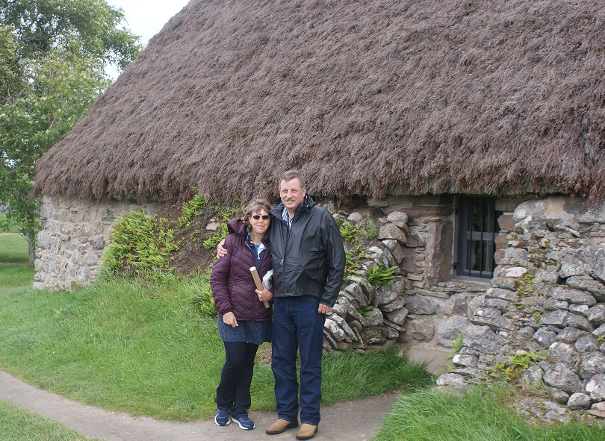

We can tailor “experiences” for individuals, couples, families and groups, you give us your “hit list” and we will plan around it, expect a few surprises thrown in. There is a lot to see and do in Scotland and we are masters at getting the most out of our homeland, of working around the weather we are so famous for and of ensuring you have an amazing time here in Scotland.

A Typical Tailored Experience:
Well clearly there is no such thing, everyone is unique, we can and will cater for that.

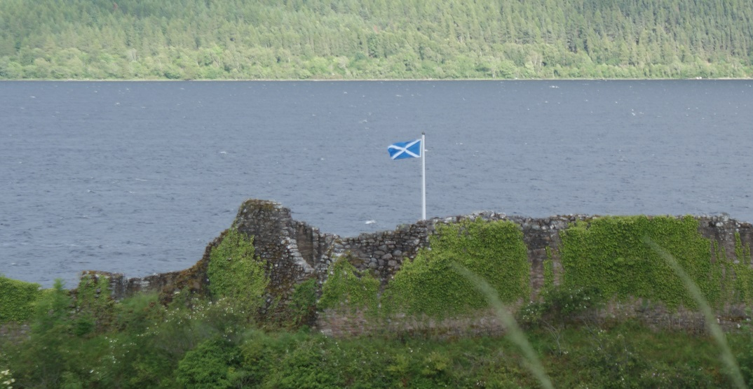
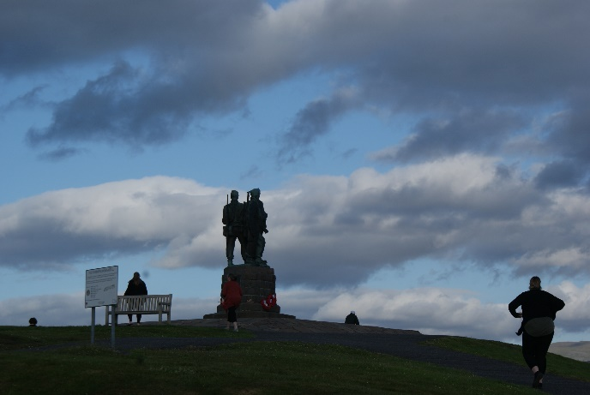
What’s Included in your Tailored Experience?
- Transport both ways from local pick up point (as near as possible)
- Dinner and Breakfast, tea, coffee, soft drinks (vegetarian options will be available)
- All equipment for overnight camping including a covered portable toilet
- Driver/Guide
- Anything else you wish to add in (within reason)

What’s not included:
- This will be down to specific requirements

Cost:
To cost a tailored experience we have a model, included in the model is time, distance, size of group, any discount for children, attractions visiting etc. Once we have input all your information the model spits out a total cost which can be broken down to individual cost if required. Rest assured we will never inflate prices or take advantage; it is just not our way.

