BackPacker Experience
“Quality, Fairness, Value”

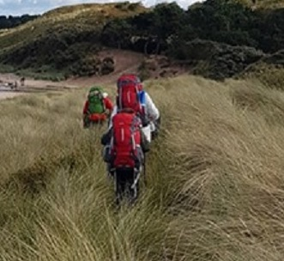

The Mountain Men Ltd
2nd Floor, Clyde Offices
48 West George Street
Glasgow
G2 1BP

0141 4827005
info@mountainmen.scot
www.mountainmen.scot

The BackPacker Experience

Description:

Our BackPacker Experience is the ultimate in wild camping in Scotland. An all-inclusive package we supply everything you need from a rucksack to a head torch and everything in between.
The BackPacker is designed to get you out, to show off Scotland and to take you away from the normal tourist spots. As the name suggests there is an amount of walking involved and carrying a pack. Nothing we do and nowhere we take you will be beyond your limits no matter what your level of fitness is.
If you want to see those lesser known, less accessible beauty spots in Scotland then the BackPacker Experience is the way to do it.

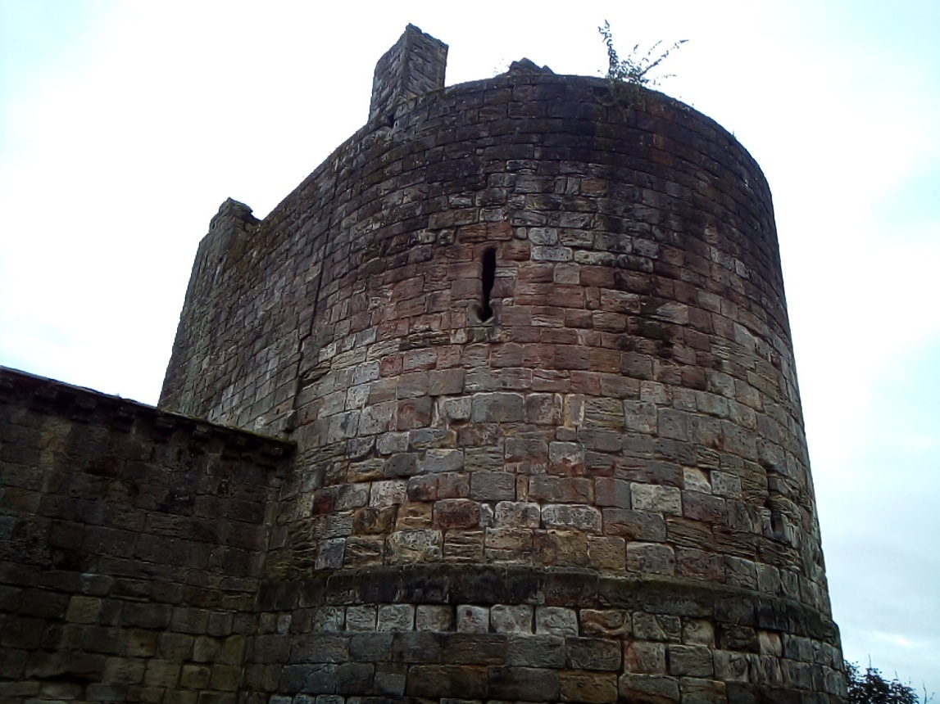

Now despite the fact you will be carrying everything you need in a pack on your back there is no need to worry, we will supply you with the best of equipment to ensure a comfortable night and as the gear is all lightweight it will not break your back. An average pack will weigh between 10 – 12kg depending on any extra stuff that you bring. A word on that, you can bring with you some luxury items and maybe a change of clothes but there is really no need for you to worry about equipment, we even supply toilet wipes and hand sanitiser in your pack. We really have thought of everything.

A Typical BackPacker:

Your day will start with pick-up, we will arrange with you a suitable local pick up location, a main street close to where you live (as best as is practicable). Once all pick-ups are complete and we have a cup of coffee or tea we will make our way on our journey. Exactly where you are going will be a mystery to you, we love the big reveals.
On route we will stop somewhere for lunch, a local pub, café or even restaurant depending on what is available, lunch is not included in the cost so it is entirely optional, you are welcome to bring a packed lunch with you if you prefer.
After lunch we will be making our way to your night-time destination, don’t be fooled by direction though as we are masters of deception, you may be travelling South and end up North, it’s all a mystery.
Whilst travelling we will try to make your journey as interesting as possible, if there is something on route we simply should visit then we will, it may be a castle, a beach, a waterfall etc, our job is to showcase Scotland and her beauty and culture, we will do this in Mountain Men style, relaxed and no time pressure.
And then on to the night location and we promise you it will be simply stunning.

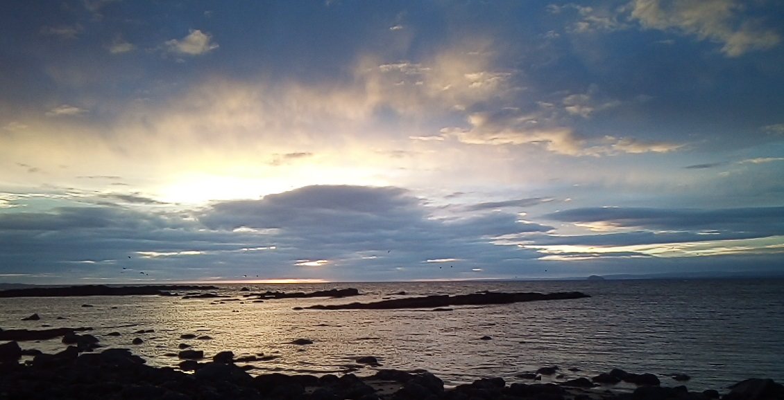

On arrival at the night-time location we will prepare camp, we will always have a minimum of one Mountain Man on hand and we will assist in setting up the tents and the camp.
Once camp is set you are free to explore, there are no timings for dinner or indeed breakfast, you will have your own stove and cooking gear and can therefore make dinner whenever you feel hungry, brew up in your own time etc. Most meals will be boil in the bag so no need to pack culinary skills. In the morning you can breakfast at your leisure, we are not going to hurry you away, enjoy the relaxation, have a lie in, wake early to explore more, your decision.

What’s Included in your BackPacker Experience?
- Transport both ways from local pick up point (as near as possible)
- Choice of Dinner and Breakfast, (vegetarian options will be available)
- Tea and Coffee packs
- Fully packed rucksack with everything you need from tent and sleeping bag to toilet items
- Driver/Guide

What’s not included:
- Lunch
- Entry to any attraction we stop at
- Return travel from your pickup location (we will endeavour to come as close to you as practicable)

Cost:
Currently the BackPacker Experience retails at £87.50 per person (incl all taxes). Family and Group bookings may attract a discount, please enquire prior to booking.

